PRESS FILE

Complete control
Smart building automation means less stress thanks to unlimited control possibilities

Schlierbach, Stuttgart – 1.9.2019. Technical developments are often fascinating and meet with enthusiasm, wherever they might be happening. Life without a smartphone or tablet is something we can now scarcely imagine. And while people in some areas are looking to slow down, when it comes to digitalisation the opposite is often the case. People eagerly await new features and solutions as these provide greater creature comforts in the home.

When time is of the essence and things have to be done quickly, even the most banal tasks can cause stress. Have I lowered the roller shutters, turned off the lights, turned down the heating? Dealing with these and other problems is something that we will probably never be able to avoid entirely. But elero now has a solution that allows you to have everything under control. Centero Home is the name given to the smart system that allows for the operation of building technology using a smartphone or tablet. It functions as a central control unit, bundling the functions of all the integrated devices in the Centero Home Box. Visual and sun protection, lighting, heating elements, motion detectors and much more can be operated and managed comfortably from the couch with the user app or remotely via the cloud. Even long-term planning is possible: using the calendar function it is possible to exclude scenarios that have already been saved, under which roller shutters are to be raised and lights switched on at 7.30 for example, for individual days or vacation periods. In addition, it is possible to determine individually which devices are to be classified as “critical” and thus monitored – regardless of whether you are at home or not. If windows are defined as critical in the system, for instance, a warning symbol appears on the start screen as soon as one is opened. And thought has also been given to protecting the home and personal property: if residents are on vacation or a business trip, Centero Home makes sure the house appears to be occupied. For example by opening the roller shutters at random times, automatically turning on the lights at dusk or playing music although the residents are still away from home. Those wishing to enjoy even more smart home benefits can upgrade to the Plus version of Centero Home thanks to an in-app purchase. Among other things this gives you the possibility to control all the devices integrated into the system using voice control. Further information is available under https://www.elero.com/en/applications/examples-of-use/home-automation/
[2.645 characters with spaces]

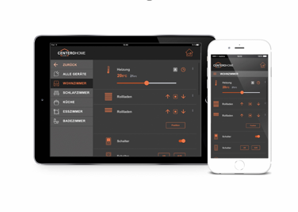
Image 01
Centero Home is the ideal entry level product for the smart home universe. In addition to visual and sun protection, it is also possible to integrate building technology and security components as well as lifestyle products from other manufacturers, and to operate these using a smartphone or tablet. (Photo: epr/elero)

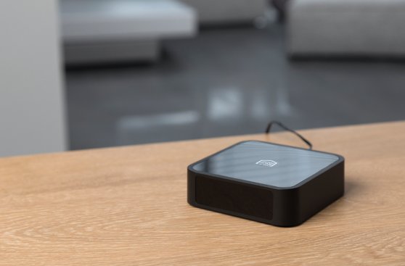
Image 02
Centero Home functions as the central control unit and bundles the functions of all the integrated devices in the Centero Home Box. (Photo: elero)

Image 03
The in-app upgrade to the Plus version offers an abundance of functions and applications which make the home even smarter and thus ensure more creature comforts in the home: for example being able to control all taught-in devices using a voice assistant. (Photo: elero)

Image 04
Regardless of whether anyone is at home or not, with the Centero Home app it is possible to view the status of the building technology and adjust this individually at any given time. (Photo: elero)

Elero GmbH
elero, situated in Schlierbach near Stuttgart, Germany, is one of the leading manufacturers of drives and controls for roller shutters, sun protection systems and rolling doors. A division of elero is also commited to the development and production of electric linear actuators. elero's product line is very versatile and offers a wide range of drives and controls as well as an extensive variety of electrical and mechanical accessories. The drive manufacturer is a wholly-owned subsidiary and independent premium brand for screen automation solutions within Italy’s Nice Group, a multinational provider of products in the fields of Home Automation, Home Security and Smart Home. www.elero.de

