elero: Orange is the new blue
elero makes its strategic reorientation more visible with new company logo

Schlierbach, 27.04.2022 – elero – the long-standing company from Baden-Wuerttemberg, Germany – has a new logo. The colour orange has now been superseded by blue, and the addition “a Nice company” has been replaced with “Sun Shading Solutions Nice”. In this manner elero is making its strategic reorientation much more visible, says Inge Rappold, Head of Marketing: “Demand for modern sun shading solutions has grown continuously in recent years. This development has led to us bundling our strengths with our parent company Nice to a greater extent over the years, and within the Nice group we have become the specialist for sun shading. We therefore offer products and solutions from both brands: elero and Nice. And it is this promise which we have now integrated into our new logo.”

Quality and innovation
elero is thus officially what the company has represented for some time now: the “Sun Shading Solutions” address within the Nice Group. The new colour and the addition indicate two things therefore: the experience of elero as a long-standing German company and the strength of the global player Nice. “We continue to stand for innovation and quality ‘Made in Germany’, and as to date we attach great significance to collaboration with the specialist trade on the basis of partnership. At the same time this bundling of know-how drives product innovations, as illustrated by the example of Yubii Home,” says Inge Rappold. The new smart home system Yubii is a complete solution for trade partners and goes far beyond the simple automation of sun shading. The gateway is compatible with many products from elero and Nice – and also with more than 3000 devices from other brands. This gives the specialist trade more options, allowing them to offer their customers an integrated, individual solution from one source.

Sustainable changeover
The changeover of all materials will be conducted gradually by elero, also for sustainability reasons, as Inge Rappold explains: “We will use all the existing stationery and promotional literature until these have been depleted as sustainability is one of the declared objectives of Nice, and naturally it is also dear to our hearts.” The new complete catalogue has already been produced in the new design and the web presence also updated. In the middle of the year elero will be making available a modular point of sales solution in the new design for its partners.

Strong presence for the entire group
For Juan Pablo Boz, Chief Marketing Officer at Nice, the new branding was also an important step for the entire group: “With the new branding Nice is underlining the changes of recent years. The company was founded nearly 30 years ago and ever since it has grown considerably, both in terms of geography and its product range. So as to ensure clear recognition and a uniform appearance we have overhauled our branding and are pleased that our strengths are now also reflected in the logos of our subsidiaries.”

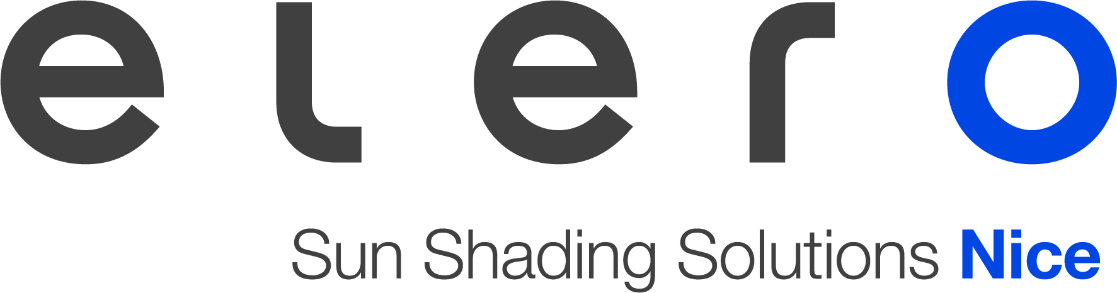

About elero
elero, based in Schlierbach near Stuttgart, is one of the world's largest manufacturers of electric drives and control units for intelligent building automation. A second business unit in Pößneck, Thuringia, develops and manufactures electric linear actuators. The drive manufacturer is a wholly-owned subsidiary of the Italian Nice group, a global manufacturer of smart home, security and building automation solutions, and specialises within Nice in the roller shutter and sun protection sector.
www.elero.com

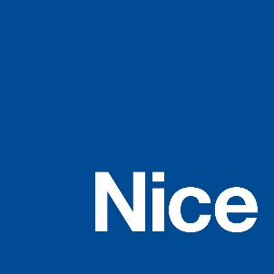

About Nice
Founded in the early 1990s, Nice is a world leader in the Smart Home, Home Security and Home and Building Automation markets. It has a comprehensive offering of integrated solutions for the automation of gates, garage doors, solar protection, parking systems, wireless alarm systems and home security in residential, commercial and industrial buildings. Nice has launched a strategic plan to expand and broaden its portfolio of products and connected platforms. It offers a wide range of customizable and easy-to-use options for the end user and seeks to strengthen and expand in markets with high growth potential, improving and renewing ist brand to compete in new market segments. Nice exports its products, which combine technological innovation and design, to more than 100 countries.
www.niceforyou.com
LinkedIn I Facebook IFacebook Twitter I Instagram
#nice #niceforyou #smarthome #homesecurity #homeautomation

Contact

Wächter PR Deutschland
Tanja Gottwald
+49 (0)89/74 72 42-75
t.gottwald@waechter.team
elero – Sun Shading Solutions Nice
Inge Rappold
+49 7021 9539-319
Inge.Rappold@elero.de

Nice – Global Press
Elisa Chies
el.chies@niceforyou.com

