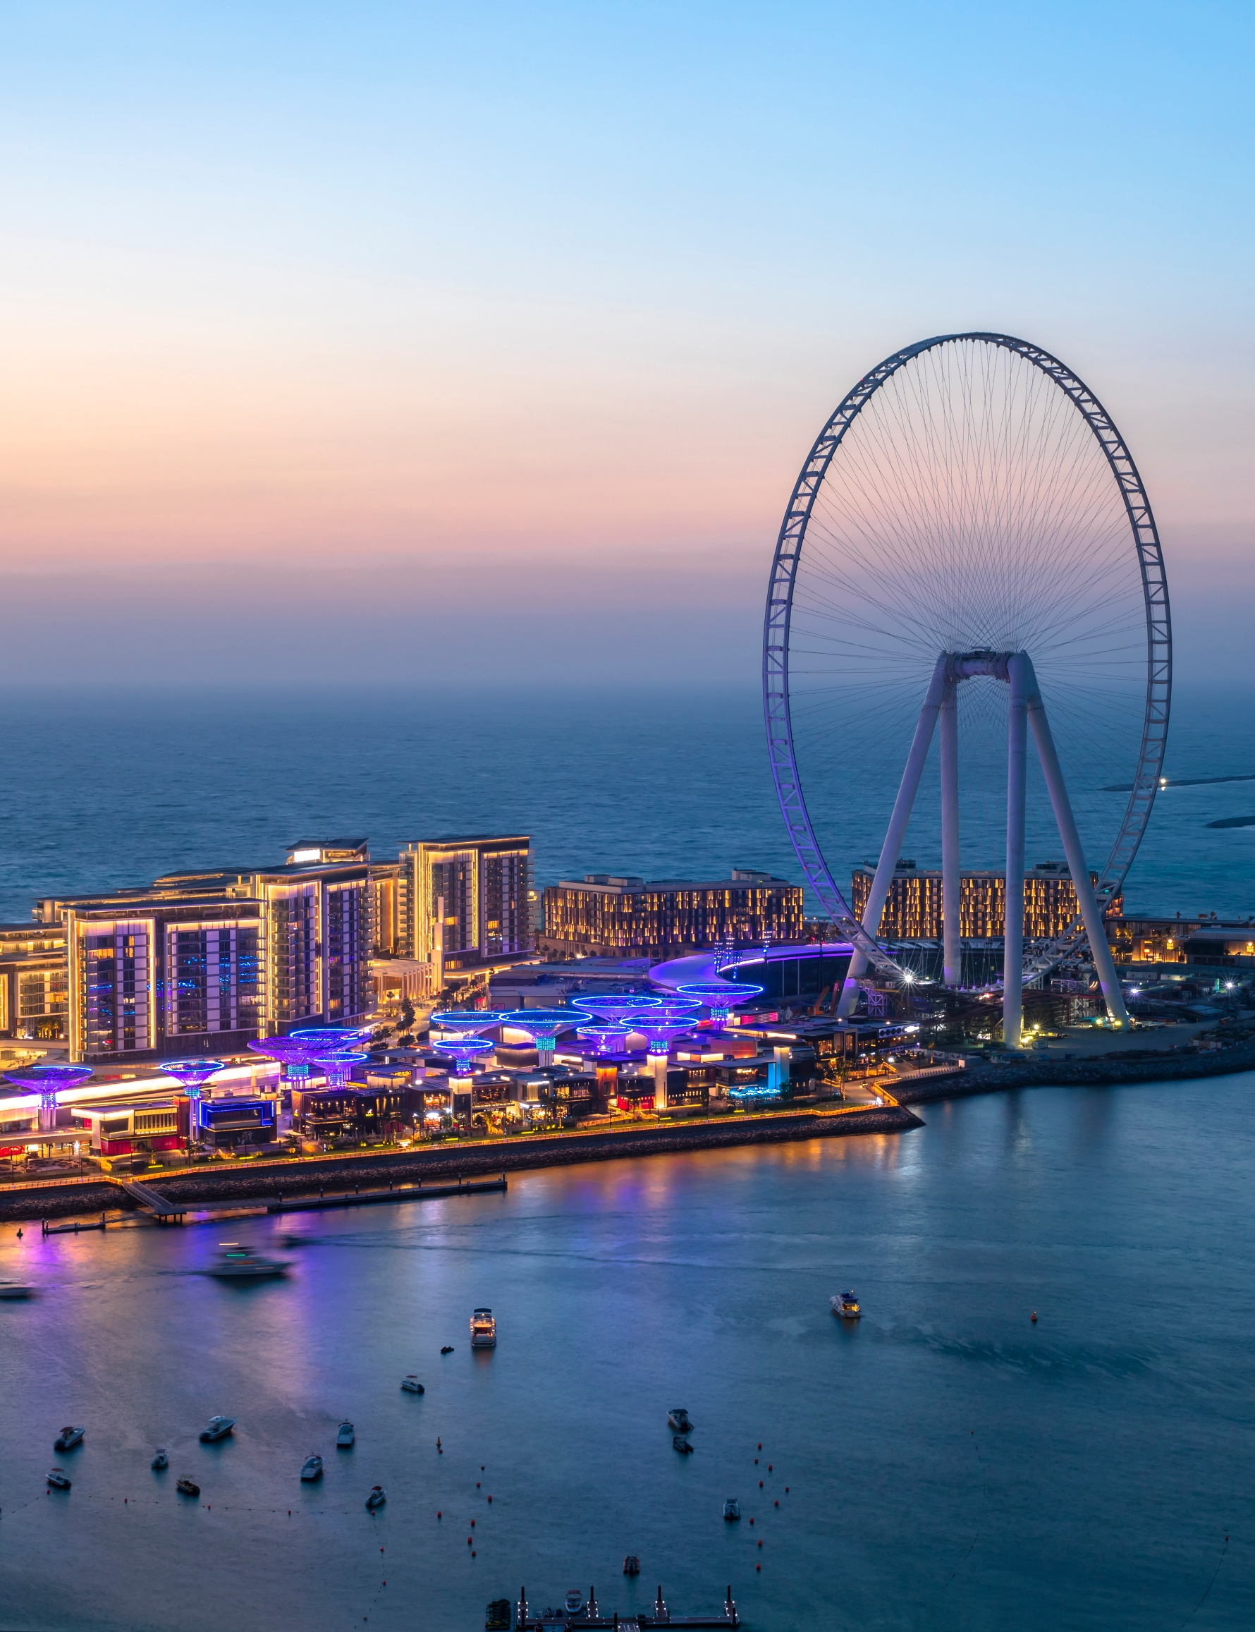

Press release
Nice automation systems
in the wonderful setting
of Bluewaters Island in Dubai

Nice automation systems in the wonderful setting of Bluewaters Island in Dubai

Nice systems for the automation of access control,
which are synonymous with reliability and high performance,
have been chosen for the futuristic residential complex

Milan, July 2020 - Nice, the Italian multinational company leader in the Home Automation, Home Security and Smart Home sectors, confirms once again a leading reality in the avant-garde city of Dubai with the installation of its automations in the Bluewaters Island complex.

Bluewaters Island is Dubai’s new vibrating centre: it hosts residential and commercial solutions, over 200 accommodation and entertainment activities, including a series of elevated panoramic gardens, to offer residents and tourists multiple opportunities of excellent quality. The focal point of the complex is the Ain Dubai Ferris wheel which, with its height of over 250 metres, conquers the world record and it is set to become one of the most famous tourist attractions in the world.

The location of the Bluewaters’ artificial island, right in front of the Dubai Marina and near the famous Jumeira Beach, offers a new and exciting view of the entire Dubai bay. An oasis of peace outside the hustle and bustle of the city, still easily accessible thanks to the well-structured connections. In addition to a relaxing pedestrian walkway and a monorail system of public transport, the island is easily accessible by car via a bridge connecting the mainland to the spacious underground car parks.

Nice was selected by Meraas Group, the owner of the project, and Woods Bagot, the Architect who coordinated the works, as the ideal partner for the realization of the parking area management systems. The implementation consists of around 40 M3BAR units, barrier systems for access control, customized according to the specific needs of the context.

Regarding this opportunity Oleg Zakarov, General Manager of Nice Gulf, comments: “It is an honour for us to be present in the key points of a city like Dubai, which is an expression and symbol of avant-garde and futuristic vision. It is indeed a confirmation of Nice's reliability as an ideal partner for large projects with high complexity, and in those cases which require flexibility to ensure customizations that make the product perfectly responsive to the customer's needs".

The NiceBar range is the optimal solution for road access control in parking areas, private and condominium walkways, even with high traffic intensity. The characteristics of reliability and high performance lasting over time, the essential and elegant design accompanied by careful research of materials, make Nice solutions a choice of greater comfort and safety, in any context.

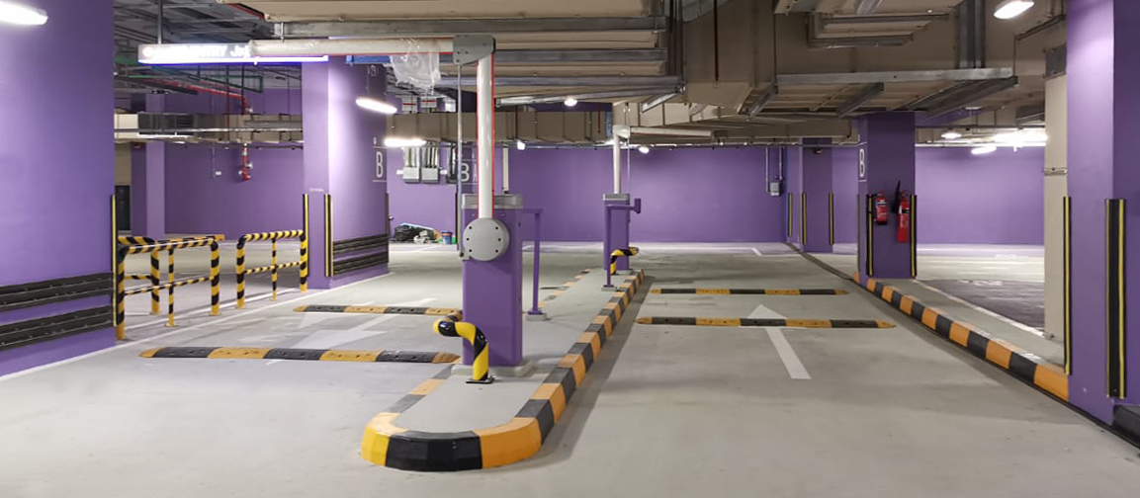

In particular, the NiceBar range allows to manage the movement of two opposing automations
in intelligent mode: this feature called “Primary/Secondary System”, together with the obstacle detection technology, guarantees maximum safety and performance both in terms of access control, as well as for the users of the service. Furthermore, regarding the energy saving, when it is not in use, the system goes into stand-by reducing consumption. At the same time, the optional batteries placed inside the motor prevent any blackout.

For more information on the Nice installation, visit the website www.niceforyou.com.

Nice

Italian multinational company based in Oderzo (TV) with a strong international vocation, Nice is an international leader in Home Automation, Smart Home and Home Security with the aim of combining functionality and design to simplify people's daily gestures. Nice is synonymous with technology and excellence: its solutions are used worldwide and applied in public and private spaces, such as airports and prestigious locations. Thanks to its founder and current Chairman, Lauro Buoro, and the 2.300 professionals who work every day to achieve the company's objectives, the Nice group distributes its products in over 100 countries around the world, with 24 branches on 5 continents, 14 production units and 13 research and development centres.
www.niceforyou.com
Contacts:
Nice – Eleonora Prodomo Nice – Marta Gemin
Ph. +39 0422 505 572 Ph. +39 0422 505 615
e.prodomo@niceforyou.com m.gemin@niceforyou.com

